School Name : SUPPORT PLANNER – QUICK REFERENCE

BASIC PRINCIPLES
- The Planner is only a tool
- Use requires judgement of cost, value and risk
  - Enter least data for most value
  - Flag sensitive content, eg, "Difficult family situation, see AP"
- The Planner is best understood as a communication system
- 5% data + 95% human interaction: conversations and coaching
- Two kinds of data
  - Observations = information about the student: including, needs performance, what’s working, what’s not, other possibilities, queries…
  - Support actions (including arrangements)
- Data is useful for
  - Compiling formative assessment (gathering and organising observations)
  - Establishing needs (from patterns)
  - Planning and managing support actions (at least three kinds - see below0
  - Monitoring: knowing
    - what's working and what is not
    - what's being done and what is not
  - Working with others and making it easier for them to understand and do well
  - Demonstrating accountability - competence and care
- Behaviour is an indicator of student need (albeit, often an 'urgent need')
- Combine two approaches to support
  - Start with "What works for this student?"
  - Add "What is needed for this student?"
- There are several levels of response to students needs
- The best response is the one that matches to the needs of the student (and others) in
- Reponses include consideration of the present context, and also the past and future
- Three measure of progress (in 'order of appearance')
  - Time between incidents/concerns is increasing
  - Recovery time is getting shorter
  - Concerns are lessening
- Codes make
  - data entry and analysis easier
  - and patterns more visible
- Planner Conventions
  - Dates are always entered as 12/3 (for this year) or 12/3/09 (for other years)
  - Dialogue boxes- simply press OK to get <All> ...
- Bookmark the site index of the Support Planner website
History: 10 years in development; used in almost 50 Tasmanian schools & clusters

MAIN MENU

1. Warning

The Support Planner is for professional use only according to school policy. See also the Disclaimer

2. Hyperlinks
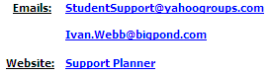 | Emails to  - the whole discussion group  - or to Ivan  The website has a wealth of information

3. Four possible views of student data
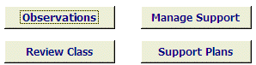 | - Observations: incidents, concerns, achievements, queries...  - Manage Support: opens with support actions  - Review Class: selects students in a particular class, eg, 8B  - Support Plans: selects only those students with individual support plans
Note: each view provides access to all the student's data

4. Other task pathways from the Main Menu
More MAIN TOOLS  - Search Observations  - Search Support  - Check Agreements  - Monitor Goals  - REPORTS  - Alert staff | Quick Checks  - Update Support  - Update Observations  - Manage Student Ratings  - Support Matrix - workload on main support staff  Managing documents  - Templates  - Student Files | Management  - Add/place Students  - Edit Codes  - Edit Classes  - Management Tasks  - Class Lists

STUDENT DATA (Observations view)

5. Basic student details
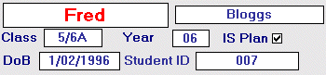 | Note: this student has an Individual Support Plan (box ticked)

6. Navigation between students
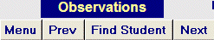 | Use these buttons to move from one student to another

7. Student History
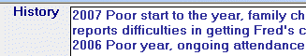 | A very succinct overview of the student and his/her context  Note: reverse order ensures that the latest history is at the top of the record

8. Alert re student
Vital information for anyone who deals with the student

9. Student Performance/Needs ratings
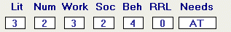

10. The current Goal for student
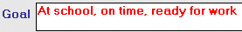 | This goal is the current short term goal for this particular student - the next achievable step

11. Tabs (for accessing groups of data about the student)
- Observations 30 days
- Observations - All
- Support Actions
- IS Plan
- Agreements
- Timetable (exceptions)
- Contacts/Programs

12. Observations (several types) re student
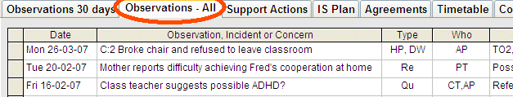
- Incidents are events that occur at a place and time - C:2 means "in the Classroom in period 2"
- Reports are information from various parties: difficulties, improvements, feedback...
- Queries are questions/possibilities raised by various parties
Includes Resolutions (responses) and possible related hyperlinked References (documentation)

13. Support actions (three main types)
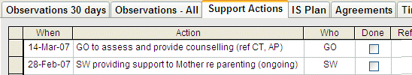
- One-off interventions eg, GO Assessments
- Extended interventions, eg, SW support to family, or special programs
- Everyday support - see Individual support plan (below)

14. Everyday Individual Support Plan (ISP)
Everyday support initiatives relating directly to the achievement of the goal

This goal is the current short term goal for this particular student - the next achievable step
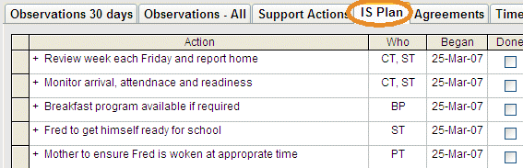
This data is used to generate a weekly checklist to enable
- prompt attention to the plan
- receiving feedback (what's working what is not)
- monitoring progress by building a daily record on a weekly basis W=33A44

15. Student Reports
For easy printouts of particular sets of data relating to the student being viewed
And for students with an ISP (available from the Support Plan view only)
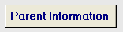
To the student's family (sample)
- The school's current goal for the student
- What has been happening lately (recent observations)
- Everyday things being done to support the student (ISP)
And also
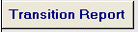
Collates most data about the student into a single report

REPORTS
From the Main Tools on the Main Menu – click the reports button

Name | SUPPORT REPORTS (subject to data entered) | Enter
Support Provider - to do | List outstanding tasks for a support provider | Code for Support Provider, eg, GO
Provider - Activity Report | List all tasks for a support provider since (date) | Starting date, Code for Support Provider, eg, GO
Class Support - to do | Class lists showing support actions outstanding for each student | Class name, eg, 5/6C
Class Support Histories | Class lists showing all support actions for each student | Class name
Class Histories | Class lists showing the History of each child in the class | Class Name
Class Student Goals | Class lists showing the current goals for each student | Class Name
Current Agreements/Plans | Listing of uncompleted Agreements or plans | Year, eg, 09
Agreements - Class Lists | Class list showing uncompleted Agreements or plans | Class Name
Alerts | Listing of Alerts with | Alert Contains, eg, CO
ISP Weekly Checklist | Class lists for all students receiving Positive Support Planning | Class name
ISP Results - Variable | ISP results for particular students or classes | Days previous
Current Codes | Lists codes currently entered into the Planner | n/a
MEETING REPORTS
Meeting Report | Lists all outstanding support actions up to 60 days ahead | Class or all
Mtg Report 30/60 | All support actions completed in past 30 days and outstanding up to 60 days ahead | Class or all
RATINGS
Class Ratings | Class lists showing ratings, suitable for updating | Class or all
Needs & Levels | Lists of students with particular Needs | Need code &/or level
Needs by Class | Lists of students with any need (by class) | Class or year code
OBSERVATION REPORTS
Observations - Today | Lists Observations that happened today as name suggests
Observations - Yesterday | As name suggests
Observations - Variable | Lists Observations/Concerns during the past (chosen) number of days | Days past (calendar days)
Observations - Day and class | As above but for a particular class | Class and Days Past
Observation - 2 weeks | As name suggests
Individual Observations - variable days | Lists Observations for a student over past (chosen) number of days | Surname and Days Past
Unresolved Observation | As name suggests - good for follow through | Year or all
OBSERVATION / INCIDENT STATISTICS
Categories - last 60 days | Observations statistics for chosen Type in last 60 days | Type of Observation
Categories - all year | Observations statistics of chosen Type for year to date | Type of Observation
Observation Type Statistics | Observations statistics of chosen Type in last N days | Type of Observation, no. of days
Observation Descriptions | Observation statistics by description (inc. clever codes) | Search for (text), eg, 'stone'
Observation Resolutions | Observation statistics by description (inc. clever codes) | Search for (text), eg, TO/
Location & Times: | Statistics on Observation Locations & times (if coded) | Days past
Our Codes (to be edited by your school)

---SUPPORT PROVIDER CODES----
Aide = TA
Being Literate Tr = BL
Case Worker = CW
Class Teacher = CT
Cluster Support = CS
Duty Teacher = DT
ESL Teacher = ESLT
Flying Start = FS
Guidance = GO
Learning Support Tr = LST
Mgt Team = MT
Parent/Guardian = PG
Relief Teacher = RT
Social Worker = SW
Speech Pathologist = SP
Support Staff = SS
Student = ST
Tr of the Deaf = TOD

-----INCIDENT CODES-----
Accident (well being)
Self = AS
Others = AO
Property = AP

Bullying = B
Verbal = BV
Physical = BP
Exclusion = BE

Harm (well being)
Self = HS
Others = HO
Property = HP

Disruption (success)
Work = DW
Play = DP
Non Co-operation = DN

Offense (well being)
Peers = OP
Staff = OS
Community = OC

Unsafe Action
Out of Bounds = UO
Throwing Objects = UT
Unsafe Action = UA

Care Concern: CC
Disclosure = D

-------RESOLUTIONS------
Agreement = AG/
Aides Play Group = APG/
Communication Book = CB/
Contract CR = CCR/
Contract PG = CPG/
Discussion with MT = DMT/
Discussion with Tr = DiT/
Exclusion = E/
External Suspension = ES/
Internal Suspension = IS/
Parent Contact = PC/
Quiet time sit & think = Q/
Red Room = RR/
Relocation = RL/
Time Out = TO/
Verbal& Visual reminder = V/
Walk with Duty Tr = WDT
Went Home = WH/

----------NEEDS---------
AD = ADD
AH = ADHD
AS = Asperger's syndrome
AU = Autism
CP = Cerebral Palsy
DD = Developmental Delay
DS = Down's syndrome
FX = Fragile X syndrome
HI = Hearing impaired
SL = Specific Learning Difficulty
UD = Undiagnosed
VI = Visually impaired

------LOCATIONS-------
B = Bus
C = Class
O = Oval
P = Playground
S = Specialist
T = Canteen (‘tuckshop’)
W = Way to/from

--------TIMES-----------
B = Before school
1 = Block 1
R = Recess
2 = Block 2
L = Lunch
3 = Block 3
A = After school

